Object-Oriented Programming (OOP)

📌 Definition:
# Source: AI Source: Provided by: [Data Path: Persons Table -> ID Column: 1, Name_En Column: Motasem Essam] -> From: [Chatgpt (GPT‑5 Mini)] on [12/9/2025]
Object-Oriented Programming (OOP) is a paradigm that organizes code into objects, which combine data (attributes) and behavior (methods).

🧠 Simple idea:
# Source: AI Source: Provided by: [Data Path: Persons Table -> ID Column: 1, Name_En Column: Motasem Essam] -> From: [Chatgpt (GPT‑5 Mini)] on [12/9/2025]
OOP = “Everything is an object” 🧩

🔍 Key concepts (4 pillars):

📦 Encapsulation
# Source: AI Source: Provided by: [Data Path: Persons Table -> ID Column: 1, Name_En Column: Motasem Essam] -> From: [Chatgpt (GPT‑5 Mini)] on [12/9/2025]
- Bundles data + methods together
- Protects data from direct access

🔁 Inheritance
# Source: AI Source: Provided by: [Data Path: Persons Table -> ID Column: 1, Name_En Column: Motasem Essam] -> From: [Chatgpt (GPT‑5 Mini)] on [12/9/2025]
- One class can inherit properties from another
- Promotes code reuse

🎭 Polymorphism
# Source: AI Source: Provided by: [Data Path: Persons Table -> ID Column: 1, Name_En Column: Motasem Essam] -> From: [Chatgpt (GPT‑5 Mini)] on [12/9/2025]
- One method can behave in different ways
- Same interface, different behavior

🧱 Abstraction
# Source: AI Source: Provided by: [Data Path: Persons Table -> ID Column: 1, Name_En Column: Motasem Essam] -> From: [Chatgpt (GPT‑5 Mini)] on [12/9/2025]
- Hides complex details
- Shows only necessary features

📌 Example (C++ style):
# Source: AI Source: Provided by: [Data Path: Persons Table -> ID Column: 1, Name_En Column: Motasem Essam] -> From: [Chatgpt (GPT‑5 Mini)] on [12/9/2025]
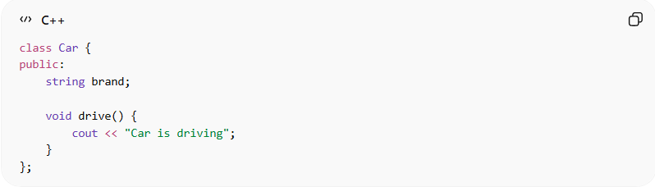
class Car {
public:
string brand;

void drive() {
cout << "Car is driving";
}
};

Using the object:
# Source: AI Source: Provided by: [Data Path: Persons Table -> ID Column: 1, Name_En Column: Motasem Essam] -> From: [Chatgpt (GPT‑5 Mini)] on [12/9/2025]
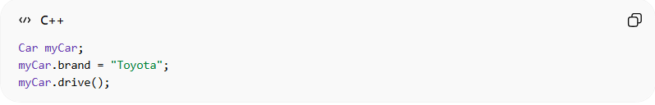
Car myCar;
myCar.brand = "Toyota";
myCar.drive();

⚙️ Real-world languages:
# Source: AI Source: Provided by: [Data Path: Persons Table -> ID Column: 1, Name_En Column: Motasem Essam] -> From: [Chatgpt (GPT‑5 Mini)] on [12/9/2025]
- 🟢 Java
- 🟢 C++
- 🟢 C#
- 🟢 Python (supports OOP)

🆚 OOP vs Procedural
# Source: AI Source: Provided by: [Data Path: Persons Table -> ID Column: 1, Name_En Column: Motasem Essam] -> From: [Chatgpt (GPT‑5 Mini)] on [12/9/2025]
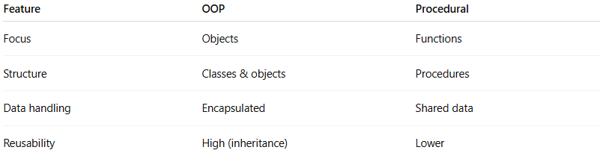
Feature | OOP | Procedural
Focus | Objects | Functions
Structure | Classes & objects | Procedures
Data handling | Encapsulated | Shared data
Reusability | High (inheritance) | Lower

🎯 Summary:
# Source: AI Source: Provided by: [Data Path: Persons Table -> ID Column: 1, Name_En Column: Motasem Essam] -> From: [Chatgpt (GPT‑5 Mini)] on [12/9/2025]
OOP organizes programs into objects that combine data and behavior, making code more modular, reusable, and easier to manage.

